Significant differences in determinations of mean global surface temperature trends for recent decades
Richard S Courtney
RSC Environmental Services, 88 Longfield, Falmouth, Cornwall, TR11 2TD, UK

This paper was rejected by Nature in 2003 because the Editor said that “Comparison of data sets does not have sufficient importance to warrant publication.” It is provided here so readers can judge the importance of the information for themselves.

Synopsis
The UN Intergovernmental Panel on Climate Change (IPCC) IPCC has concluded there is “increasing evidence” for an anthropogenic influence on the global climate⁽¹⁾. This conclusion is based on assessments of two independent determinations of the mean surface temperature of the globe since year 1880 ^{(2),(3),(4)(5)}. These determinations are each obtained by analyses of the temperature measurements mostly made at weather stations, so any difference in their indications must result from their different analysis methods. Until now these data sets have been assessed by comparison of their indications of changes to indications of annual temperature anomalies. It is argued here that the rate of change indicated by linear regression analysis over the most recent 30 years is the most valid comparison of the data. And it is shown here that these determinations disagree this indication of the rate of change by 42%. At present, there is no method to determine which, if either, analysis method is correct. Hence, there exists no reliable indication of the rate of change to mean global surface temperature and, therefore, the IPCC conclusion is not tenable.

The UN Intergovernmental Panel on Climate Change (IPCC) has considered studies using climate models to assess annual mean global surface temperature of the Earth since 1880 ⁽¹⁾. And, on the basis of these studies, the IPCC has concluded that ⁽¹⁾ solar forcing dominated causes of changes to the temperature throughout the first half of the twentieth century, but anthropogenic forcing (i.e. enhanced greenhouse gas radiative forcing) dominated causes of changes to the temperature throughout the latter half of the century.
The IPCC accepts two data sets that each provides empirical values of annual mean global surface temperature since year 1880 ⁽¹⁾. These are the data provided by
- the Global Historical Climate Network (GHCN) ^{(2),(3),(4)}, and
- Jones et al.⁽⁵⁾ .
These data sets each provides values of anomalies to annual mean global surface temperature compiled from temperature measurements mostly made at weather stations. They each indicate that the mean global surface temperature varied throughout the twentieth century, and this mean temperature had a rising trend throughout the latter three decades of the century.
The model studies attempted to determine the causes of the variation to mean global surface temperature since 1880. Values of radiative forcings were input to the models, and the models were used to predict annual mean global temperature since 1880. The values of the input forcings were adjusted until agreement was obtained between the model predictions and empirical values of the temperature throughout the assessed period. These studies determined that the model predictions matched the empirical values when the model was adjusted so solar forcing dominated the first half of the century and the anthropogenic forcing dominated the latter half.⁽¹⁾
The above IPCC conclusions would not be tenable if the model studies had matched the model predictions to empirical data containing gross errors.
This paper reports that the IPCC conclusion is not tenable because linear regression analyses of the GHCN and Jones et al. data sets indicates a gross error in their indications of the rate of mean global surface warming for the most recent 30 years.
The GHCN and Jones et al. data sets are each derived from the same measurements of temperature (mostly at weather stations). These measurements are processed to obtain the mean global surface temperature. Hence, any difference between their indications of rate of change to the mean global surface temperature must result from the different assumptions and procedures adopted to obtain the two data sets of mean global temperature. If they provide similar climate indications then this would provide confidence that they both use correct methods. But if they have significant disagreement then it would be known that at least one of them uses a method that is not correct.
For the most recent 30 years (i.e. 1972 to 2001), the Jones et al. and GHCN data sets each indicates a rising temperature trend. The individual values for the data throughout this period are provided as Table 1, and are shown graphically as Figures 2 and 3.

Table 1. Annual mean global surface temperature anomalies for the period 1972 to 2001 provided by GHCN and Jones et al
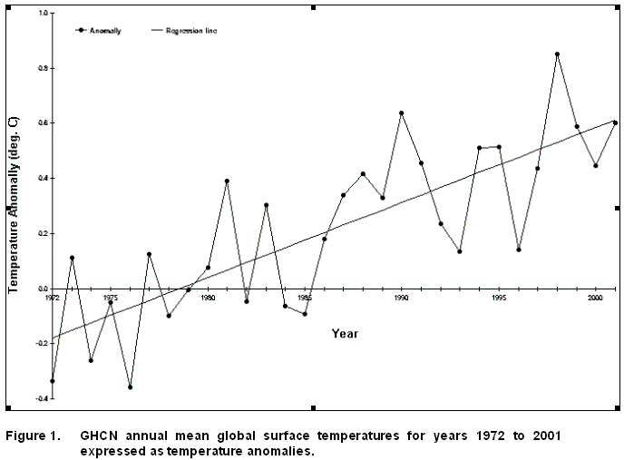

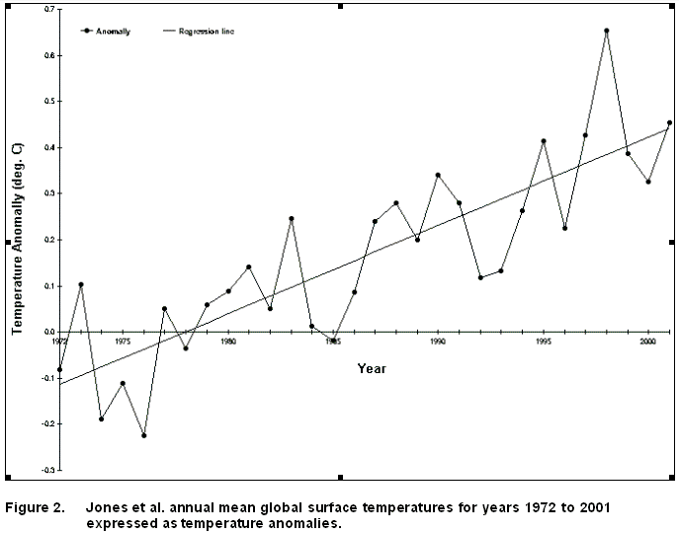

Results of the regression analyses are provided as Table 2 and are included in Figures 1 and 2.

Statistic | GHCN data | Jones et al. data
Number of years | 30 | 30
Slope | 0.0273 p.a. | 0.0192 p.a.
Intercept | -54.0 | -37.9
Explained Variance | 62.42 % | 70.21 %
Confidence of the line | Above 99% | Above 99%

Table 2. Results of linear regression analyses conducted on annual mean global surface temperature anomalies for the period 1972 to 2001 provided by GHCN and Jones et al..

GHCN gives a linear regression trend of 0.273 deg. C/decade
and
Jones et al. give a linear regression trend of 0.192 deg. C/decade
This is a difference of 0.081 deg. C/decade (i.e. 42% of the Jones et al. rate and 30% of the GHCN rate).

There is no known method to determine which, if either, of these data sets uses a correct method. Therefore, in the absence of an independent measurement of mean global surface temperature, all that can be said of these data sets is that they disagree the rate of recent mean global surface warming by 42%. And, therefore, at least one of these data sets is generated using incorrect methodology.
The above considers linear regression trends of change to mean global temperature – not changes to individual annual temperature anomalies – over the last 30 years. Reasons for this analysis warrant mention because previous assessments of these data sets have considered their indications of annual changes to their temperature anomalies. Hence, it could be argued that only changes to individual annual temperature values are comparable and/or the selected time period is not appropriate.
The IPCC conclusion utilises mean global surface temperature change as an indicator of climate change. Climate is the integral of weather over a period of time, and the normally accepted minimum period (e.g. by IPCC) is 30 years. This definition requires that climate data be compared over minimum periods of 30 years: annual data is weather. Hence, valid assessment of climate data sets is conducted over minimum periods of 30 years. And linear regression is an appropriate method to assess change over a minimum period.
Hence, the GHCN and Jones et al. data sets can provide useful indication of climate change only if they are demonstrated to agree the rate of change to mean global temperature as indicated by linear regression over a period of 30 years. And they can only provide useful data for matching to the model predictions of climate change if they demonstrate this agreement between each other. But it is shown here that they disagree this rate of change by 42% over the most recent 30 years (i.e. the period 1972 to 2001).
The period 1972 to 2001 is considered to be the most important for the data sets to show agreement because
- 30 years is normally accepted (e.g. by IPCC) as the shortest period for which climate data can be stated,
- the most recent data should be most trustworthy, and
- the IPCC asserts the model studies indicate that anthropogenic warming is the major cause of the global surface temperature trend over this period.

The discrepancy between the GHCN and Jones et al. data sets may be capable of resolution by comparison with other measurements. If another measurement system gave similar indication to one of these sets then this would give confidence to the methods used to generate that set.
Over recent decades, the mean tropospheric temperature has been independently measured using microwave sounding units (MSU) mounted on orbital satellites ⁽⁶⁾ and radiosondes mounted on weather balloons ⁽⁷⁾. The MSU data has been obtained since 1979 and the radiosonde data since 1958. They each indicate fluctuations in the tropospheric temperature, but show negligible rise in temperature over the last 30 years for the radiosonde data and since 1979 for the MSU data. The MSU data can only be compared for the period since 1979 when these measurements began, but the radiosonde data can be compared for last 30 years as well as the period since 1979.
The MSU, radiosonde, GHCN and Jones et al. data sets all have the same pattern of temperature fluctuations (i.e. times when temperature rose and fell).
Trends for the MSU and radiosonde data are
radiosonde gives a linear regression trend of
0.085 deg. C/decade for 1972 to 2001 and -0.027 C/decade for 1979 to 2001
while
MSU gives a linear regression trend of 0.054 deg. C/decade for 1979 to 2001.
There is a perhaps coincidental similarity between the radiosonde trend (0.085 deg. C/decade) and the difference between the GHCN and Jones et al. trends (0.081 deg. C/decade) for the period 1972 to 2001. The difference is significant as an indicator of the accuracy of the GHCN and Jones et al. data sets. But a trend of less than 0.1 deg. C/decade has negligible significance when considering need for immediate action to counter potentially harmful climate change.

Summarising the above
1. the measurements of mean tropospheric temperature obtained using MSU mounted on orbital satellites and radiosondes mounted on weather balloons each show negligible warming over recent decades, and they validate each other,
while
- the different determinations of global surface temperature by Jones et al. and GHCN each show significant warming over recent decades, but they invalidate each other.

Research to resolve these differences deserves a high priority when the IPCC has stated its above conclusions based on the data of GHCN and Jones et al..

References

- Intergovernmental Panel on Climate Change, “Climate Change 2001: The Scientific Basis”, Cambridge, 2001
- Peterson, T.C. and Vose, R.S. 1997. An overview of the Global Historical Climatology Network temperature data base. Bulletin of the American Meteorological Society 78: 2837-2849.
- Peterson, T.C., Vose, R.S., Schmoyer, R. and Razuvacv, V. 1997. The quality control of monthly climate data. International Journal of Climatology 18: 1169-1179.
- Peterson, T.C., Karl, T.R., Jamason, P.F., Knight, R. and Easterling, D.R. 1998. First difference method: Maximizing station density for the calculation of long-term global temperature change. Journal of Geophysical Research - Atmospheres 103 (D20): 25,967-25,974.
- Jones, P.D., Parker, D.E., Osborn, T.J. and Briffa, K.R. 1999. Global and hemispheric temperature anomalies -- land and marine instrument records. In Trends: A Compendium of Data on Global Change. Carbon Dioxide Information Analysis Center, Oak Ridge National Laboratory, U.S. Department of Energy, Oak Ridge, TN, USA.
- Christy, J.R., Spencer, R.W., and Braswell. 2000. MSU Tropospheric Temperatures: Dataset Construction and Radiosonde Comparisons. Journal of Atmospheric and Oceanic Research 17: 1153-1170.
- Angell, J.K. 1999. Global, hemispheric, and zonal temperature deviations derived from radiosonde records. In: Trends: A Compendium of Data on Global Change. Carbon Dioxide Information Analysis Center, Oak Ridge National Laboratory, U.S. Department of Energy, Oak Ridge, TN, USA.

Correspondence and requests for materials should be addressed to Richard S Courtney.
(e-mail: RichardSCourtney@aol.com).

